**Missouri Trout Fishermen’s Association**

(Tagged fish only)

**MTFA-State Trout Derby (tagged fish only)**

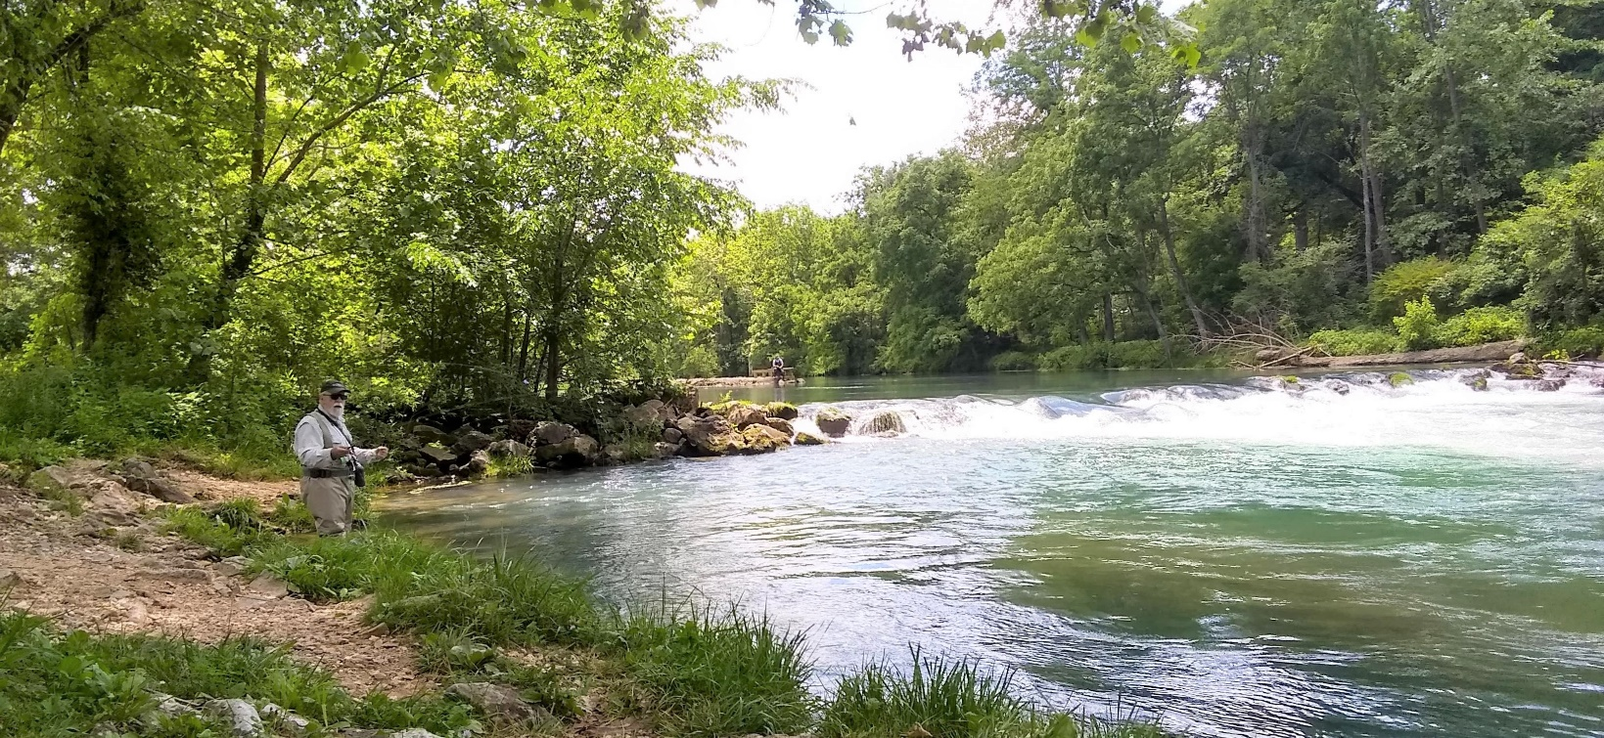

**Bennett Spring State Park**

**May 20 & 21, 2023**

**We are encouraging a $5.00 (donation) as an entry fee to the**

**MTFA Derby. This event can be a great chance to meet other**

**anglers that share your passion for trout fishing,**

**win prizes and fishing itself can be fun too.**

**Registration at Park Store**

**Registration starting approximately 7:00pm Friday evening (May 19th) until store closes and Saturday (May 20th) from 5:30am until 8:00am.**

**Derby Rules available when you Register.**